darren@darrensilcox.com Text Box 1Text Box 3

07986 271306

**Projects & Brands**

Here are just some of the projects and companies I have had the opportunity to work with.

Project involvement varies and can be discussed remotely or one to one.

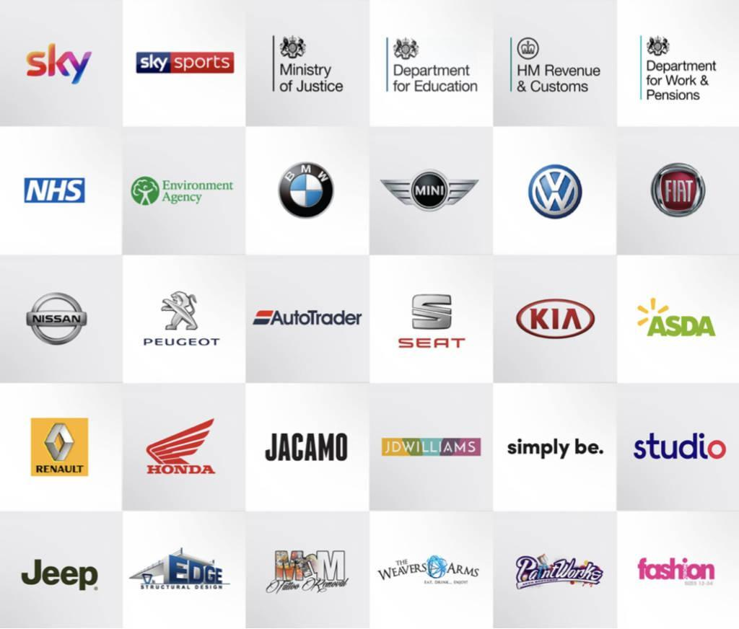

**Links**: Some government projects could be password protected, these can be demonstrated remotely or one to one.

| <https://www.ukri.org/>  <https://www.gov.uk/using-your-gov-uk-one-login>  <https://www.sky.com/>  <https://www.skysports.com/>  [https://flood-warning-information.service.gov.uk](https://flood-warning-information.service.gov.uk/warnings)  <https://www.gov.uk/power-of-attorney>  <https://digital.nhs.uk/>  <https://www.autotrader.co.uk/>  <https://www.sytner.co.uk/>  <https://usedcars.bmw.co.uk/>  <https://usedcars.volkswagen.co.uk/>  <https://www.usedcars.peugeot.co.uk/>  <https://usedcars.jeep.co.uk/>  <https://used-uk.kia.com/>  <https://usedbikes.honda.co.uk/>  <https://usedcars.jeep.co.uk/>  <https://usedcars.honda.co.uk/>  <https://usedcars.renault.co.uk/> | <https://www.asda.com/>  <https://groceries.asda.com/>  <https://direct.asda.com/>  <https://www.jacamo.co.uk/>  <https://www.jdwilliams.co.uk/>  <https://www.simplybe.co.uk/>  <https://www.marisota.co.uk/>  <https://www.fashionworld.co.uk/>  <https://www.vivaladiva.com/>  <https://www.studio.co.uk/>  <https://www.edgestructuraldesign.com/> |
| --- | --- |

**Experience Timeline…**

“Historically most of my jobs have been contracts, long and short term, I am ideally looking for a permanent position but will accept contracts until I find the right perm position.

**Senior UX/UI Designer - DHSC - Department for Health & Social Care**

**July 2024 – Sept 2024**

I have been working on the Alpha phase of a project to build an Adult Social Care data portal. As part of the alpha requirements I built designs in figma, mapped out the as is and to be to form part of the services design. Designs were then tested and iterated throughout the alpha phase.

**Senior UX/UI Designer – UKRI - UK Research and Innovation**

**Dec 2023 – Mar 2024**

Working for the UKRI gave me a chance to work on one of the biggest complex systems yet. Working with Developers, B.A’s Testers, Project Managers, Product Owners and other Designers alike, I applied GDS principles and solid user experience understanding to a funding application based system. One of the projects I worked on was for an external client OfGem where they required a slightly bespoke application service for the private sector.

**Senior Interaction Designer – GDS - Cabinet Office**

**Jul 2023 – Oct 2023**

Joining the Government Digital Service(GDS) was an opportunity to work on something quite different and also be exposed to different ways of working. As a UCD team within a larger agile team we worked in Figma to work up designs then build them in the prototype kit and then take them to users to test. This was all part of a new government project called One Login.

**Interaction Designer – HMRC**

**Feb 2022 – Apr 2023**

Working for HMRC gave me the opportunity to work on a big service called “paying tax from previous years or the digital disclosure service". I worked on this project from discovery right through to live. Although this was a revamp to replace an outdated i-forms service, we got the opportunity to satisfy many business and user needs. We also built the service making it comply with all the latest accessibility standards.

**Lead UX Designer / Researcher – Insolvency Service**

**Aug 2021 – Oct 2021 Remote**

Working for the Insolvency Service was a great insight into how business and individuals become insolvent. I was part of a small team of two BA’s a User Researcher and a Project Manager. This was an eight-week discovery to unearth problems with some of the current services, map out pain points, map out the as is and plan potential solutions. I also help with research and interviewing.

**Lead UX Designer - Education and Skills Funding Agency (ESFA) (Methods)**

**Nov 2020 – Jul 2021 Remote**

Joining the Education and Skills Funding Agency (ESFA), was a unique experience as there was lots of projects going on and a team of 8 designers. Overarched by the Department for Education (DFE) which has a much wider design community, there was a great opportunity for collaboration and inspiration and sharing. Once again prototyping with the GDS toolkit I contributed to a service where apprentices confirm new apprenticeships whilst providing an online portal where apprentices can see what's expected of them and their training provider or employers. This service is about to launch into a private beta phase soon going live.

**Lead UX Designer -Transport for the North**

**Jun 2020 – Nov 2020 Remote**

Working for Transport for the North as an interaction designer working within GDS guidelines this included using the prototype kit, testing with users and working closely with user researchers. The project was to provide a system where transport companies could upload their fares and route data, this information could be used open-source to develop app and link into google. I contributed to the project through alpha into a private beta phase.

**UX Designer / User Researcher – Sky (Leeds)**

**Oct 2019 – Feb 2020**

Working with Sky was a great opportunity, positioned in the Sky Sports and Sky News area, I worked on a variety of projects. The main project was a discovery project for the information architecture and navigation of the Skysports website with attracts upwards of 50 million unique visitors a month.

I also accompanied other UX designers on the development of the SkyQ interface on a voice activated football highlights project. Both projects required research analysis, wire framing, tree testing and lab testing.

**Lead UX Designer - Ministry of Justice (MoJ)**

**Criminal Injuries Compensation Authority (CICA)**

**Jan 2019 – June 2019 Glasgow**

My focus and skills included using the Gov Design System, communicating information, evidence and context-based design, understanding constraints, user centric design, prototyping in code, community calibration and strategic thinking. As a part of a team, I was working on a project so victims of abuse can claim compensation. I also worked on a service for power of attorney.

**Lead UX Designer - Department for Education (DfE)**

**Aug 2018 – Oct 2018 Manchester**

The problem was teacher shortages, and the scope was getting potential teachers experience in school environments. The output at the end of Alpha was a GDS prototype that profiled users, a find and book system and a management facility for schools this project passed its Alpha GDS assessment

**Lead UX Designer - HM Revenue & Customs (HMRC)**

**Mar 2018 – Aug 2018 Shipley**

HMRC was a faced paced pressurised environment and gave me great understanding of processes and regulation surrounding; Importing, Exporting, Duty, Excise and VAT. I developed personas, sketched out user flows, studied service pain points and mapped out user journeys. We tested prototypes with users, learning and iterating whilst working to agile methodologies.

**User Researcher UX Designer - NHS**

**Jan 2017 – Dec 2017 Leeds**

The brief was to provide the wider NHS with an indication and health score of crucial services. The scope was wide ranging, from GP referrals to electronic prescriptions. The vehicle for this reporting was Splunk IT Service Intelligence, this gave users the ability to view and investigate service problems and potential outages across all NHS services. I researched what users needed, developed prototypes and built interactive interfaces in Splunk.

**Interaction Designer - Department for Work and Pensions (DWP)**

**Mar 2016 – Dec 2016 Manchester**

Working at the DWP we used hypothesis driven design to develop GDS prototypes for a re-payment of crisis loans system. I also worked on an internal case management fraud system. We tested our hypothesis on users and worked in an iterative agile manner.

**Lead UX Designer - Environment Agency (EA)**

**Mar 2015 – Feb 2016 Warrington**

The EA flood warning was my first government project. We took research and prototyped how this could work then developed prototypes with the GDS toolkit, tested with users and developed the service which is currently live now.

I then embarked on the International Waste Shipments project. I worked closely with product owners and subject matter experts. The content designer and I worked with a user researcher, we tested user journeys and built pages with Axure, and then built working GDS prototypes.

**Front End Developer – Manheim & Autotrader**

**Jul 2012 – Feb 2015 Manchester**

I worked for Manheim twice and Autotrader once in this period, they were very similar roles in the same sector. I was responsible for providing UX design for the main BMW and MINI used car websites and contributed to most other popular car brands in the portfolio.

The work involved wire-framing, prototyping, design elements, templating, HTML5, CSS3, and jQuery. Using a .Net framework environment, using Visual Studio and TFS with agile sprint methodologies.

**UX Designer / Front End Developer –**

**JD Williams portfolio (20 brands)**

**Aug 2011 – Jul 2012 Manchester**

JD is a fast paced creative environment. All brands must be updated inline with the seasonal and weekly promotional calendars. Responsibilities included: conceptualisation, HTML/CSS creation and complete online store re-designs covering JD’s portfolio.

**UX Designer – ASDA**

**Jan 2009 – Mar 2011 Leeds**

Designed advertising on ASDA groceries, ASDA and George website to the value of 4m and contributed to the development of the groceries online offering. Also designed microsites, analysed and provided reporting.

**Earlier Work History**

Various permanent Web Designer and Graphic Designer positions July 1991 – Jan 2009.

**The Early Years**

I knew I wanted to be a creative designer from a young age, I was designing stuff even at school I was designing graphic literature freelancing, studying, designing marketing collateral.

In 1998, a few years later, with mountains of print, loads of CD multimedia and my fair share of exhibitions stood behind me. I was intrigued and drawn in by the internet and the potential development that that medium had to offer. Luckily I was working for an agency that was jumping in with both feet.

**The Personal Bit**

British, Born, 27th March 1974, Location Hebden Bridge

Interests include: Internet, Design, Walking, Cycling, Travelling, Snowboarding, Arts, Cooking, Dining Out, Reading, Gardening, Architecture and Building.

Currently renovating an 18th century barn in Halifax, which is proving a massive challenge.

**References available on request**